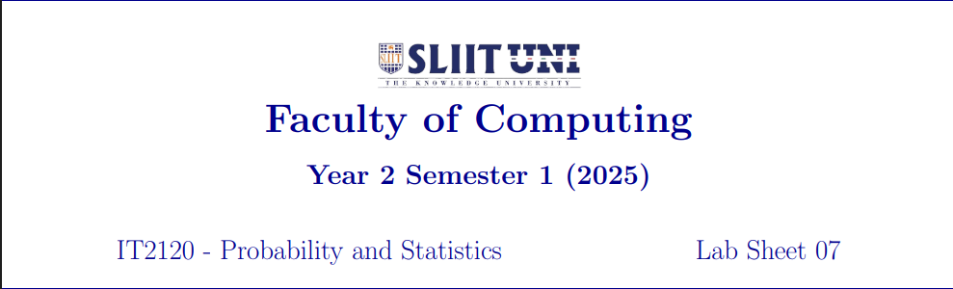
IT24100002
Jayalath W D D T
Exercise
1.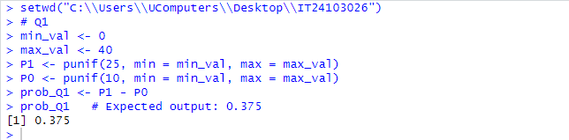

2.


3.
